Booking Form – SPANISH FAIR 2011 – Spanish October
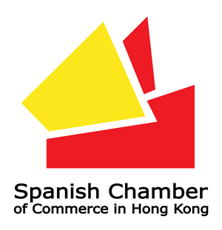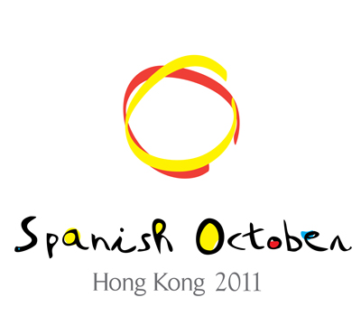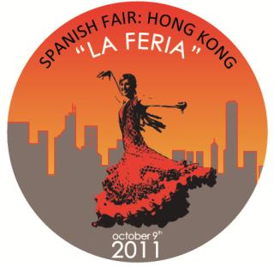

The Spanish Fair, is a combination between "Fiesta" and Fair: leisure time and business.
It is an event inspired by the Andalusian Fairs and its aesthetic, which combines sales points of products related with Spain and recreational activities: food, beverage, music and performance.

On the day, 20 Spanish exhibitors will participate to offer visitors all kinds of exciting Spanish cultural programs and gourmet foods. Other than sampling premium Spanish ham, Sangria cocktails, and top wines from Spanish regions, visitors can also immerse themselves in Spanish culture through various Spanish travel and educational organizations. The Spanish Chamber of Commerce specially invited several well-known Spanish restaurants in the city to prepare mouthwatering dishes for visitors—including a live demonstration of local specialties and beverages by top Spanish chefs, sure to captivate the audience!

To better capture the energetic passion of Spain, the Chamber has invited numerous famous flamenco dancers for a flamenco spectacle to showcase the intoxicating traditional Spanish dance. If you love to dance, don’t pass up the flamenco lessons offered at the venue for free! A designated children’s area at the venue guarantees fun for the whole family as well!
Dates: 9th October 2011
Venue: 3/F Happy Valley Racecourse, Hong Kong
Price: 100 HKD
---------------------------------------------------------------------------------------------------------------------------------------
To: The Spanish Chamber of Commerce. 7/F, Unit B-C, One Capital Place, 18 Luard Road, Wanchai. HK
Email: trade@spanish-chamber.com.hk Attention: Mr. Alberto Rodriguez or Mr. Pablo López
Tel: 3622 3072 Fax: 2763 6279

Name:
Address:
Tel: |  |  | Email:
Signature: |  |  | Total HKD:
- Payable by cheque to:
“THE SPANISH CHAMBER OF COMMERCE”
(Make sure you write the Name of your company)
- Payable by account:
THE HONGKONG AND SHANGHAI BANKING CORPORATION LTD (HSBC)
HK Account “043-237270-001”

