Booking Form – SPANISH FAIR 2011 – Kids Area
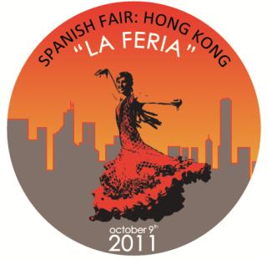

The Spanish Fair, is a combination between "Fiesta" and Fair: leisure time and business.
It is an event inspired by the Andalusian Fairs and its aesthetic, which combines sales points of products related with Spain and recreational activities: food, beverage, music and performance.

Children will enjoy this event as well in our Kids Area, since special activities will be organized by ItsImagical.

As the space is not very big the tickets are limited, please book well in advance.
Dates: 9th October 2011
Venue: 3/F Happy Valley Racecourse, Hong Kong

Time: from 12 noon to 7pm

---------------------------------------------------------------------------------------------------------------------------------------
To: ItsImagical Hong Kong Limited, 27/F, Nathan Road, Tsim Tha Tsui, Kowloon, Hong Kong
Email: Attention: Ms. Helena López Tel: 2368 2088 ext 1802 Email: hlopez@imaginarium.es

Name:
Address:
Tel: |  |  |  | Email:
Signature: |  | Age:

TERMS & CONDITIONS

- In order to be more organized and play safe, the Kids area will be limited for kids from 4 to 7 years old only.

- Service available from 12 noon to 7:00 pm

- Maximum capacity 25 kids

